**Case Study**

Magnolia’s story – caring for her momu (paternal grandmother)

**I’m a proud Yolngu woman living on Country in Yirrkala, where I was born and grew up. I’m a mum to a beautiful daughter and also a model and actress.**



**I used to live in Darwin, and I travelled**

**a lot for photoshoots, fashion shows and filming. I also work at ARDS Aboriginal Corporation, which runs creative projects for radio, media and art.**

My momu (paternal grandmother) raised me from when I was a baby and inspired me to follow my dreams. She always encouraged me to work hard and is my number 1 supporter. She’s getting older and has been unwell so I’m back home looking after her.

It’s been nice to be together again and make sure she’s ok because she did so much for me growing up.

Momu is very generous, loving and a great storyteller. She often tells me and my daughter stories of her homeland. I love when we visit and she shares beautiful memories.

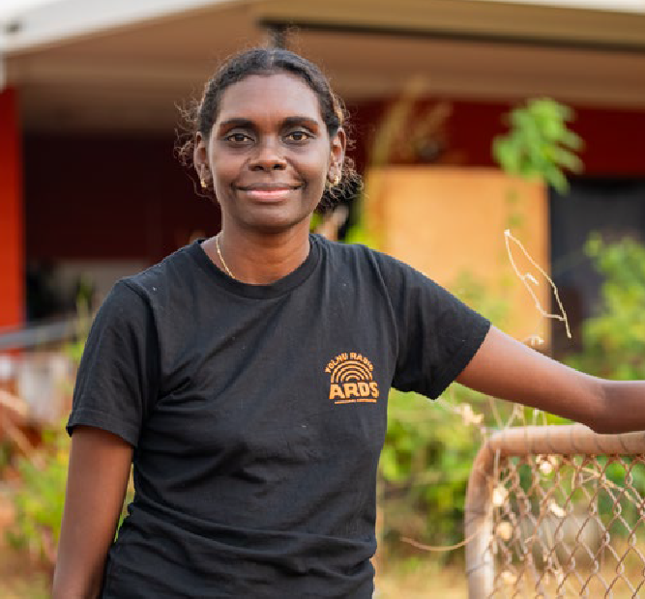

She is also strong and independent. On her good days when she feels well, I go to work but some days I stay home with her. I make sure she takes her medicine and remind her to rest because she still wants to do everything for us. It’s been hard for her that she can’t always look after us anymore.

Moving back home has impacted my career a lot. Photographers want me to be at a shoot as soon as possible but I can’t just get on a plane and go like

I used to. This is because my Momu needs me but also because of how remote where we live is, and the cost and time it takes to get to the city.

I’m happy to be home and I love the quiet and being surrounded by family and community. It’s good going down the beach to hunt and collect with my Aunties and Uncles.

Caring for my momu and living in a remote area can be hard at times. Petrol costs a lot and I have to drive a long way to take her to see doctors and get her medication. Our power sometimes goes out too and Momu worries so I have to keep her calm.

In my community and Yolngu culture we give a lot without any expectation of something in return. This is because we are all family and connected. This is who

I am but the city lifestyle is very different because your focus is just you. The opportunities I’ve had make some people think we have a lot to give but this isn’t the case. Providing, earning and giving can be tiring but I always try to have a positive mind and heart, just like momu taught me.

I didn’t know the word ‘carer’ and I didn’t realise

I am one because looking after momu is just what

I do. It was a blessing to connect with Carer Gateway because they’ve helped make things easier. It’s been nice to yarn with people who understand what it’s like

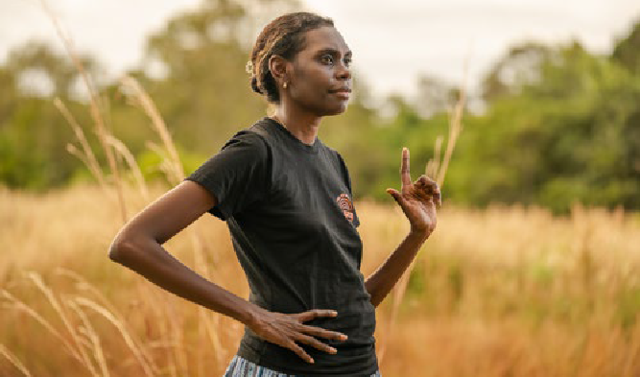

and are looking out for my wellbeing. I now know that people are always here for us and they’re just a phone call away.

Carer Gateway is there to support me and anyone caring for someone in their family or community. Carer Gateway provides free and easily accessible support, practical information and skills courses to

improve your social and emotional wellbeing and more.

***“Moving back home has impacted my career a lot. Photographers want me to be at a shoot as soon as possible but I can’t just get on a plane and go like I used to.***

***This is because my Momu needs me but also because of how remote where we live is, and the cost and time it takes to get***

***to the city.“***



Our communities are strongest when everyone is strong and it’s ok to reach out for support. To find out more about what services are available in your local area, call **1800 422 737** Monday to Friday 8:00AM to 5:00PM or visit **carergateway.gov.au/FirstNations**