**Case Study**

Tash’s story – caring for her son

**I am an Adnyamathanha woman living on Nukunu Country in Port Pirie, where I’ve lived most of my life. My Dad is from the Flinders Ranges and my Mum was**



**a part of the Stolen Generations. I’m now on the journey of reconnecting with Mum’s family in Queensland.**

I’m a proud mum to 4 beautiful kids, a grandma and sister to 6 siblings. A lot of people in my family lean on me as their rock.

One of my sons, Joel, has an intellectual disability, so I’m a mum and a carer. I make sure he gets his medication at the right time and is ok when I’m not with him. I often worry about him being safe, doing the right thing and making good choices. This worrying takes up a lot of my energy. Even with all these responsibilities, it’s the best when Joel and I sit and chat and spend time together.

Carer Gateway has helped me with looking after Joel. Sometimes people don’t know where to get support or might be too shame to ask. It’s so important to look after ourselves, do things that keep us strong and take a break.

For me, I enjoy going back to Country, sharing language, creating art with my family, and supporting First Nations businesses. I also love doing self-care activities like going to the hairdresser or getting a massage.

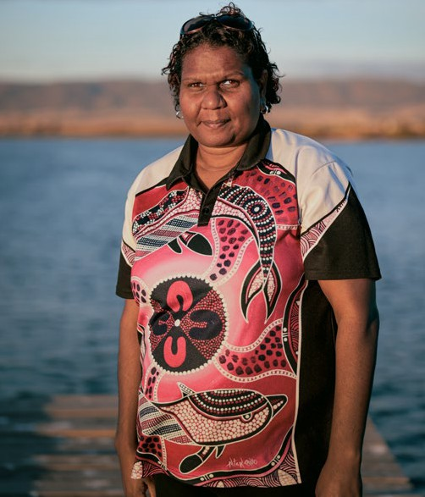

# “For me, I enjoy going back to Country, sharing language, creating art with my family, and supporting First Nations businesses. I also love doing self-care activities like going to the hairdresser or getting a massage.”

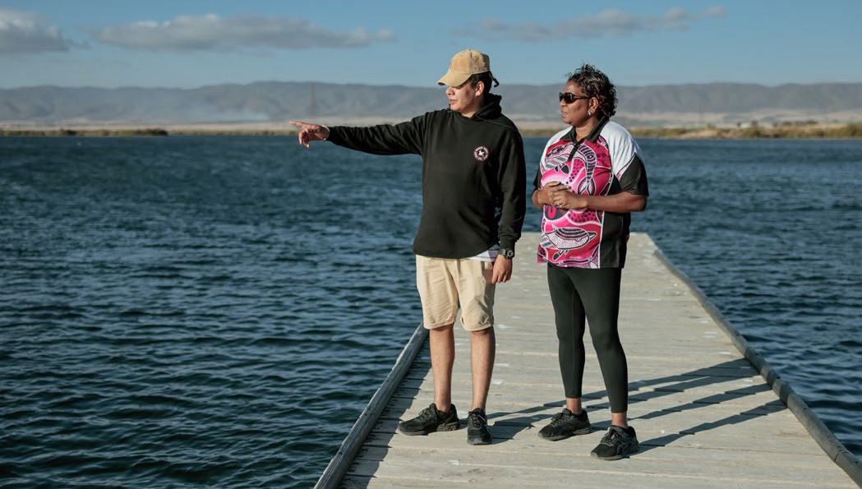

I found Carer Gateway through an Aboriginal Liaison Officer in Adeliade who has been a big support.

Without her I would never have got the help I needed. It’s important for us mob to speak to Aboriginal people in these roles. She even inspired me to share my story to help others. Carer Gateway is doing a good job supporting us carers so we can look after our families.

Carer Gateway is there to support me and anyone caring for someone in their family or community. Carer Gateway provides free and easily accessible support, practical information and skills courses to

improve your social and emotional wellbeing and more.

# “It’s important for us mob to speak to Aboriginal people in these roles. She even inspired me to share my story to help others. Carer Gateway is doing a good job supporting us carers so we can look after our families.”



Our communities are strongest when everyone is strong and it’s ok to reach out for support. To find out more about what services are available in your local area, call **1800 422 737** Monday to Friday 8:00AM to 5:00PM or visit **carergateway.gov.au/FirstNations**