

**Case Study**

Deena’s story –

caring for her dau ghter

**I am a proud Aboriginal woman living in Nipaluna (Hobart) and a mum to**

**3 beautiful kids. I love spending time with family, weaving and creating kelp baskets. I’m a child safety wellbeing worker and I provide advice and referrals to families needing support.**

My daughter, Ocean, has severe anxiety and I’m her main support. Caring isn’t just something I do, it’s a big part of who I am.

Ocean’s been anxious since she was a baby and it got worse when she started primary school. There was a point where she couldn’t leave the house, so I went to school with her every day to make sure she didn’t miss out and fall behind. She is now in high school and more independent, but there are ups and downs.

Mornings are really important in our family to make sure everyone has a good day. I go to the gym at 5am for my self-care and once I’m home I help everyone get ready. Ocean gets pretty anxious about her hair so I help her style it. She just started taking the bus by herself, which is a big step, and I drop her to the bus stop each morning. Once she is safely off to school,

I go to work. Throughout the day, I’m on call and available if she needs me.

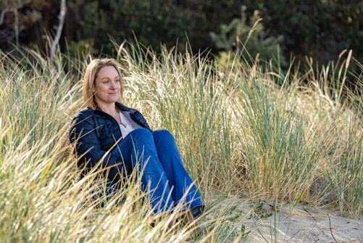

It’s honestly pretty hard being a single mum, a carer and working full-time. When Ocean was growing up my focus was her. For a long time, I’ve been a mum and carer before anything else, so I never really got the chance to get ahead financially. I was not able to work full-time consistently and move forward in my career or save money to buy a house. Worrying about money has had a big impact on my self-worth too.

***“Ocean’s been anxious since she was a baby and it got worse when she started primary school.***

***There was a point where she couldn’t leave the house, so I went to school with her every day to make sure she didn’t miss out and fall behind.”***

My life has been dedicated to supporting Ocean so that she feels safe, wanted and loved and I find it’s hard to explain this to people. It was nice when I called Carer Gateway for a yarn because they listened, genuinely cared about me and understood what it’s like.

I never knew there was support for people looking after family, like I do. A friend told me about Carer Gateway and I was able to access services including counselling and emergency respite care. This has been

really helpful and I’m now able to support Ocean better. I often refer families I work with to call Carer Gateway.

Us carers are strong, independent and empathetic and we don’t ask for help often. But there are only so

many things one person can do by themselves. Getting support is a sign of strength rather than weakness.

I now know it’s easier to prevent myself from burning out, rather than needing to recover from it.

Carer Gateway is there to support me and anyone caring for someone in their family or community. Carer Gateway provides free and easily accessible support, practical information and skills courses to improve your social and emotional wellbeing.

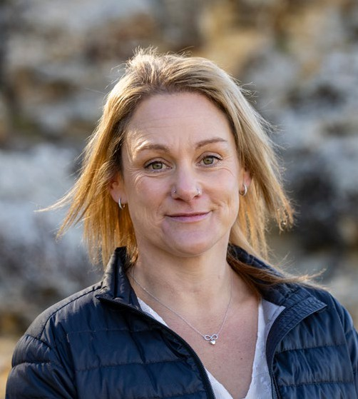

***“Us carers are strong, independent and empathetic and we don’t ask for help often. But there are only so many***

***things one person can do by themselves. Getting support is a sign of strength rather than weakness. I now know it’s easier to prevent myself from burning out, rather than needing to recover from it.”***



Our communities are strongest when everyone is strong and it’s ok to reach out for support. To find out more about what services are available in your local area, call **1800 422 737** Monday to Friday 8:00AM to 5:00PM or visit **carergateway.gov.au/FirstNations**